The Title of the Presentation
First Author, Second Author
The Name of the Faculty or Department
The Name of the University/Company
Country
e-mail: sample@sample.com

Abstract: Summary of your presentation (in approximately 150 words)
Keywords: keyword 1, keyword 2, keyword 3

Introduction
The formatting of this document indicates the editor requirements for the submission of the articles for CAADence in Architecture with some enhancements for this particular using. To make it easier for authors this document may be used as an example.

Requirements for submission of papers
Papers are to be in English on A4 paper in 12pt Cambria font. The page setup is top, bottom, left and right 3 cm. The length of the paper should not exceed 8 pages (and maximum 18000 characters). Documents should not be page-numbered.
The deadline for submission of full paper is May 10, 2016.

Formatting requirements

Title Page
The title page must give the title of the paper, all authors with their affiliations and up to five keywords. The title page shall appear as the first page of this document. The body of the text must start after the key words.

Equations
Equations should also be numbered consecutively in parentheses on the right hand side of page for reference purposes in the text.
$E=mc^{2}$ (1)

Tables and Figures
Tables, Figures and Pictures should be centered, numbered consecutively and referred to in the text as Table 1 and Figure 1.
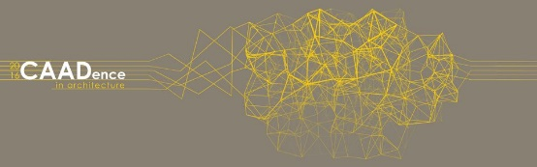
Figure 1: Description of figure

Allow at least one line space below figure descriptions and text and one line spaces above table descriptions and text.

First | Second
A | 1
B | 2
C | 3
Table 1: Description of Table

Citations
References cited in the text should be indicated by consecutive numbers in parentheses [1,2,3] on the same line as the text and the full source information listed under the heading ‘References’ at the end of paper. Examples given below: for articles in journals [1 & 2], conference proceedings [3] for books [4] and a website reference [5].

Acknowledgements
If appropriate ...

References
- Author, A. and Author, B., The Title of the Paper, Journal of Something, vol.123, 1981, p. 15-28.
- Author, A., The Title of the Book, Publisher, 1981.
- Author, A., http://caadence.bme.hu

